**Addis Ababa Institute of**

**Technology**

Department of Information Technology and Scientific Computing

Prepared by: Kaleb Besufikad

ID: ATR/7065/11

Section 1

Submitted To: Mr. Fitsum Alemu

March 6, 2020

Acknowledgment

Abstract

Table of Contents

List of figures 5

List of tables 5

The Evolution of the Internet 6

Website categories 7

1. eCommerce website 7

2. Business website 8

3. Entertainment website 9

4. Portfolio website 10

5. Media website 11

6. Brochure website 12

7. Nonprofit website 13

8. Educational website 14

9. Infopreneur website 15

10. Personal website 15

11. Web portal 15

12. Wiki or Community Forum Website 16

Website Assessment 16

1. Internet Archive - www.archive.org 16

2. Amazon - www.amazon.com 16

3. W3Schools – www.w3schools.com 17

4. WikiHow – www.wikihow.com 17

5. Hulu - www.hulu.com 18

How to evaluate websites 20

1. Authority 20

2. Purpose 20

3. Coverage 20

4. Currency 20

5. Objectivity 21

6. Accuracy 21

References 22

# List of figures

Figure 1: remove the letter 's' 9

Figure 2: four player Chess web app 10

Figure 3: The Washington Post home page 11

Figure 4. Yellowstone national park home page 12

Figure 5: the Great Wall of China homepage 13

Figure 6: malalafund.org home page 13

Figure 7: Memphis zoo's homepage 14

Figure 8: wikiHow in different languages 17

Figure 9 expert reviewed wikiHow article 18

Figure 10: Hulu first release- August 2007 (Source: Internet Archive) 18

Figure 11:Hulu's Tracker map 19

# List of tables

Table 1: List of e-commerce websites 8

Table 2: List of Business websites 9

Table 3: List of portfolio websites 10

# The Evolution of the Internet

The internet is a system architecture that allows various computer networks all over the world to share information and communicate. In the few decades of its existence, it has revolutionized the ways people communicate over long distances. However, before the internet came about to get to its current state, the constituting networks were the most advanced ways of communicating in the 1950s and early 1960s. These networks were only capable of communicating over short distances and served specific purposes. These first computer networks included the likes of the airline reservation system -SABRE and the command-and-control system for defense -AUTODIN I. By the early 1960s computer manufacturers had begun to use semiconductor technology in commercial products, and both conventional batch-processing and time-sharing systems were in place in many large, technologically advanced companies. Time-sharing systems allowed a computer’s resources to be shared in rapid succession with multiple users, cycling through the queue of users so quickly that the computer appeared dedicated to each user’s tasks despite the existence of many others accessing the system “simultaneously.” This led to the notion of sharing computer resources (called host computers or simply hosts) over an entire network. Host-to-host interactions were envisioned, along with access to specialized resources (such as supercomputers and mass storage systems) and interactive access by remote users to the computational powers of time-sharing systems located elsewhere. These ideas were first realized in ARPANET, which established the first host-to-host network connection on October 29, 1969. It was created by the Advanced Research Projects Agency (ARPA) of the U.S. Department of Defense. ARPANET was one of the first general-purpose computer networks. It connected time-sharing computers at government-supported research sites, principally universities in the United States, and it soon became a critical piece of infrastructure for the computer science research community in the United States. Tools and applications—such as the simple mail transfer protocol (SMTP, commonly referred to as e-mail), for sending short messages, and the file transfer protocol (FTP), for longer transmissions—quickly emerged. To achieve cost-effective interactive communications between computers, which typically communicate in short bursts of data, ARPANET employed the new technology of packet switching. Packet switching takes large messages (or chunks of computer data) and breaks them into smaller, manageable pieces (known as packets) that can travel independently over any available circuit to the target destination, where the pieces are reassembled. Thus, unlike traditional voice communications, packet switching does not require a single dedicated circuit between each pair of users.

The name ARPANET was used for all manners of communications between computers until 1982; which is when the name was changed to “Internet” to represent the world wide communication between computers- not to be confused with the “internet” which just refers to local connections. Even though the Internet offered a means of communication reliable at the time, establishing that very connection required much effort not to mention it was not human-friendly as it required the IP-address (a combination of numbers that points to a specific computer on the internet). This problem was solved in 1984 when the DNS servers came into action. The DNS servers mapped the IP-address from an easy to remember domain name.

Following the experimentations in linking a commercial electronic mail (e-mail) service in 1988, Tim Berner Lee prepared a proposal for the World Wide Web(WWW) to convince CERN that a global hypertext system was in their best interest. After the commercialization of the Internet, the WWW was first integrated into an application called Mosaic, the first graphical web browser made in 1993 at the University of Illinois. Mosaic, through its “point-and-click” interface, simplified access, retrieval, and display of files through the Internet.

Following the commercialization of the Internet, numerous web services started to emerge over the years. Some of the more popular web services included:

* E-commerce services such as eBay and Amazon
* Webmail services such as Hotmail
* Search engines such as Gopher and Google
* Wikipedia, Facebook, Youtube, Skype, Hulu, and many more web services

Currently, the Internet is used in almost every person’s day to day activity. It’s being used :

* to synchronize accounts across devices to create an easy workflow
* to monitor households remotely
* to have meetings without going through the trouble of traveling
* Access information in the most convenient ways possible
* Shop for items online without worrying about transportation, availability and the like
* To educate oneself on a career of choice

These are the very few things that could otherwise not have been possible if not for the development of the Internet.

# Website categories

## eCommerce website

An eCommerce website is a website people can directly buy products from. You’ve probably used several eCommerce websites before, most big brands and plenty of smaller ones have one. Any website that includes a shopping cart and a way for you to provide the credit card information to make a purchase falls into this category.

Table 1: List of e-commerce websites

|  |  |
| --- | --- |
| **Website** | **Description** |
| Best Buy - <https://www.bestbuy.com/> | It is a retailer that specializes in consumer electronics. Having developed its e-commerce shop, Best Buy sells its electronics and home appliances online to digital customers. |
| Home Depot - <https://www.homedepot.com/> | It is the largest hardware and home improvement supplies retailing company. In its brick-and-mortar shops and online store, Home Depot sells tools, construction products, home and garden equipment furniture and associated services. |
| Etsy - <https://www.etsy.com/> | Etsy is a marketplace focusing on handmade or vintage products and unique factory-manufactured items. It enables people and companies to sell a wide range of art and photography products, clothing and accessories, food, bath and beauty products, toys and diverse other items. |
| eBay - <https://www.ebay.com/> | A pioneer of e-commerce, eBay is an online marketplace that allows people and businesses to sell directly through its online auction platform. Founded in 1995, eBay has expanded to more than 20 countries, organizing the sale of products ranging from cars and vehicles to electronics and fashion, home and garden to sports and toys, and even business and industrial products. |
| Amazon – <https://www.amazon.com> | Founded in 1994, Amazon started as an online bookstore that later diversified to products including media, electronics, apparel, furniture, food, toys, and jewelry. Having expanded to many countries, Amazon has become the uncontested global leader of e-commerce and developed further into brick-and-mortar retail with the acquisition of Whole Foods Market, as well as publishing, electronics, cloud computing, video streaming, and production. |

## Business website

A business website is any website that’s devoted to representing a specific business. It should be branded like the business (the same logo and positioning) and communicate the types of products and/or services the business offers.

E-commerce websites are business websites, but it’s also possible to have business websites that don’t sell anything directly, but rather encourage visitors to get in contact for more information (a lead generation website) or come to a storefront if they’re interested in becoming customers.

Table 2: List of Business websites

|  |  |
| --- | --- |
| **Website** | **Description** |
| Myshopify - <http://myshopify.com/> | This website is linked to an e-commerce website – Shopify. This service is like a door to the latter. |
| Shopify - <http://shopify.com/> | Shopify is a website where people can start, run, and grow a business.  It provides better control over the business |
| Medallia Experience Cloud - <https://www.medallia.com> | It leads the market in the understanding and management of experience for customers, employees, and citizens. Medallia captures experience signals created on daily journeys in person, digital and IoT interactions and applies proprietary AI technology to reveal personalized and predictive insights that can drive action with tremendous business results. |
| inc - <https://www.inc.com> | It is a website that provides small business ideas and resources for the entrepreneur |
| ServiceNow – <https://www.servicenow.com> | Is a cloud-based platform and solutions deliver digital workflows that create great experiences and unlock productivity for employees and the enterprise |

## Entertainment website

These are websites that people visit purely for entertainment purposes.

* Riddles – [www.riddles.com](http://www.riddles.com)

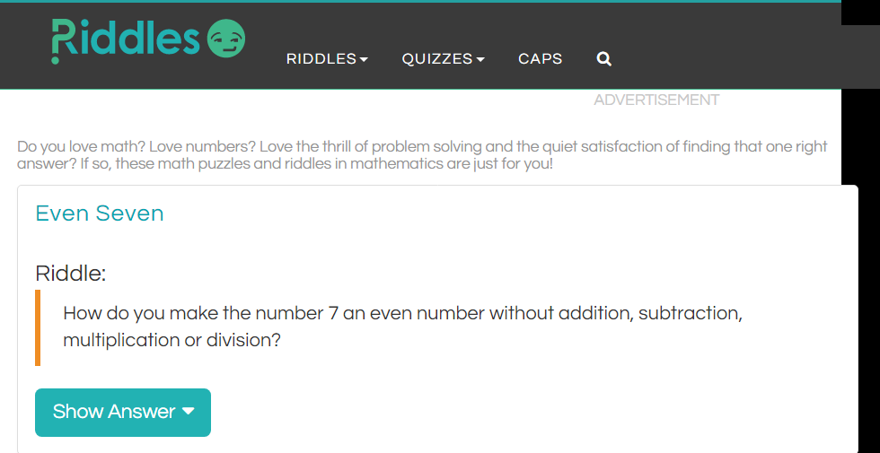

Figure 1: remove the letter 's'

Riddles.com consists of an extensive list of riddles across different themes to entertain enthusiasts.

* 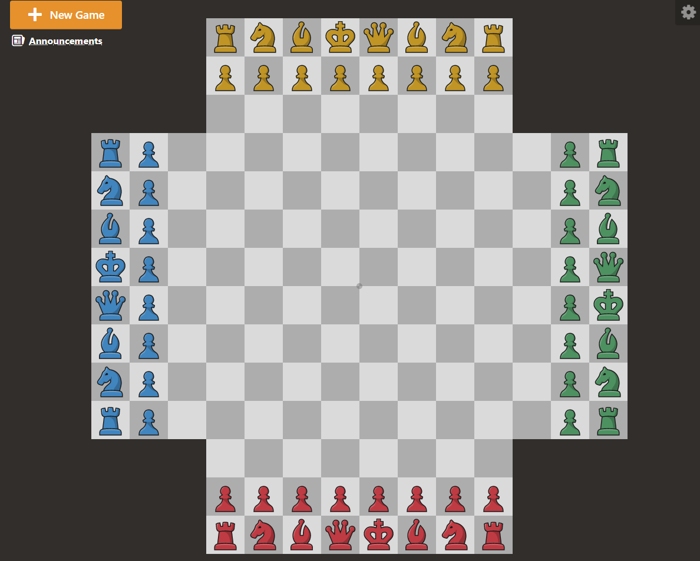Chess – [www.chess.com](http://www.chess.com)

Figure 2: four player Chess web app

* Chess.com provides the latest news on chess from around the world. Besides, it has different games that can be played through the browser.

## Portfolio website

Portfolio websites are sites devoted to showing examples of past work. Service providers who want to show potential clients the quality of the work they provide can use a portfolio website to collect some of the best samples of past work they’ve done. This type of website is simpler to build than a business website and more focused on a particular task: collecting work samples.

Table 3: List of portfolio websites

|  |  |
| --- | --- |
| **Website** | **Description** |
| <https://jazzastudios.com> | This site consists of artwork showcases created by Jazza and a shop where people can buy artwork templates prepared by Jazza |
| [www.rossdraws.com](http://www.rossdraws.com) | This site showcases digital art created by Ross and has a shop where people can buy artwork templates prepared by Ross |
| Activetheory - <https://activetheory.net> | This site is a meticulously crafted one with a highly interactive interface. It consists of projects which the active theory had previously worked on |
| Velvet Spectrum - <https://velvetspectrum.com/> | Velvet Spectrum is the online moniker of visual artist and designer Luke Choice. |
| Studio Thomas - <https://studiothomas.co.uk> | showcase different design works of studio Thomas |

## Media website

Media websites collect news stories or other reporting. There’s some overlap here with entertainment websites, but media websites are more likely to include reported pieces in addition to or instead of content meant purely for entertainment. This category includes sites like the Washington Post website, Slate, and Inc.

Many media websites are the online branch of media properties that often exist in other forms, like TV channels or print magazines and newspapers, but some are online only.

* The Washington Post



Figure 3: The Washington Post home page

The Washington Post is a famous American newspaper. It has been hosting online content reporting news since 1996.

* Inc - [www.Inc.com](http://www.Inc.com)

in addition to supporting small businesses, Inc also reports news centered around business.

## Brochure website

Brochure websites are a simplified form of business websites. For businesses that know they need an online presence, but don’t want to invest a lot into it (maybe you’re confident you’ll continue to get most of your business from other sources), a simple brochure site that includes just a few pages that lay out the basics of what you do and provide contact information may be enough for you.

Brochure sites were more common in the earlier days of the internet when businesses knew they needed a website but also expected not to be dependent on it for success. Now that the internet is such a big part of how people research and find just about every product and service they need, most businesses recognize that they need something more competitive.

A Brochure website is more like a business card- not a marketing tool but still used to bring in new business or customers.

* Yellow stone National park - <https://www.yellowstonenationalpark.com>

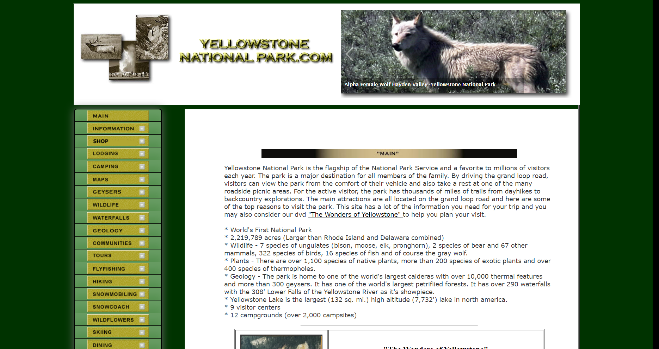

Figure 4. Yellowstone national park home page

* The great wall of china - <https://www.great-wallofchina.com>

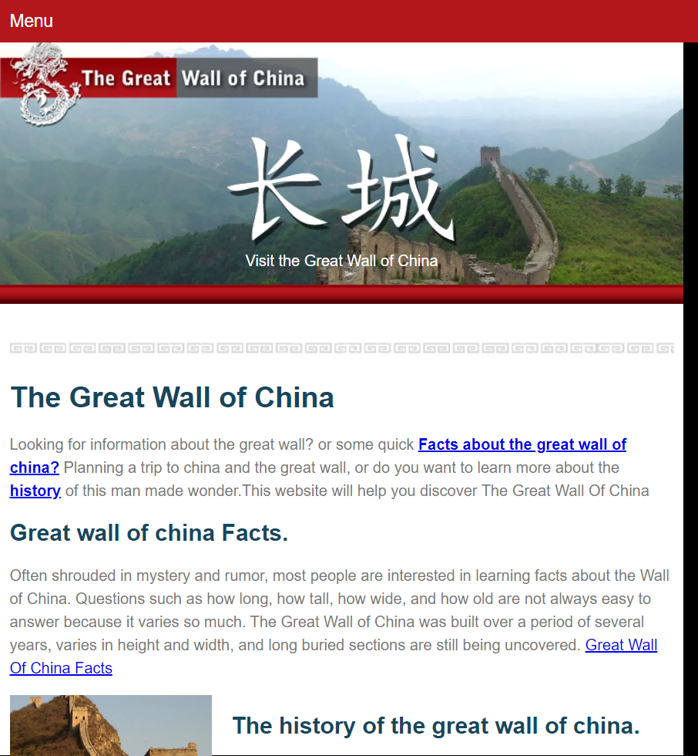

Figure 5: the Great Wall of China homepage

## Nonprofit website

A non-profit website is an easier way for many potential donors to make donations and will be the first place many people look to learn more about a non-profit and determine what they want to support.

So when you build a non-profit website to make it as descriptive as possible. Who knows! People may even feel guilty for not supporting you before if the content is convincing enough.

* Malala Fund- <https://malala.org>



Figure 6: malalafund.org home page

Malala fund is a non-profit website that spends donations it receives to help educate girls around the world with no access to education.

* Memphis zoo - <http://www.memphiszoo.org>

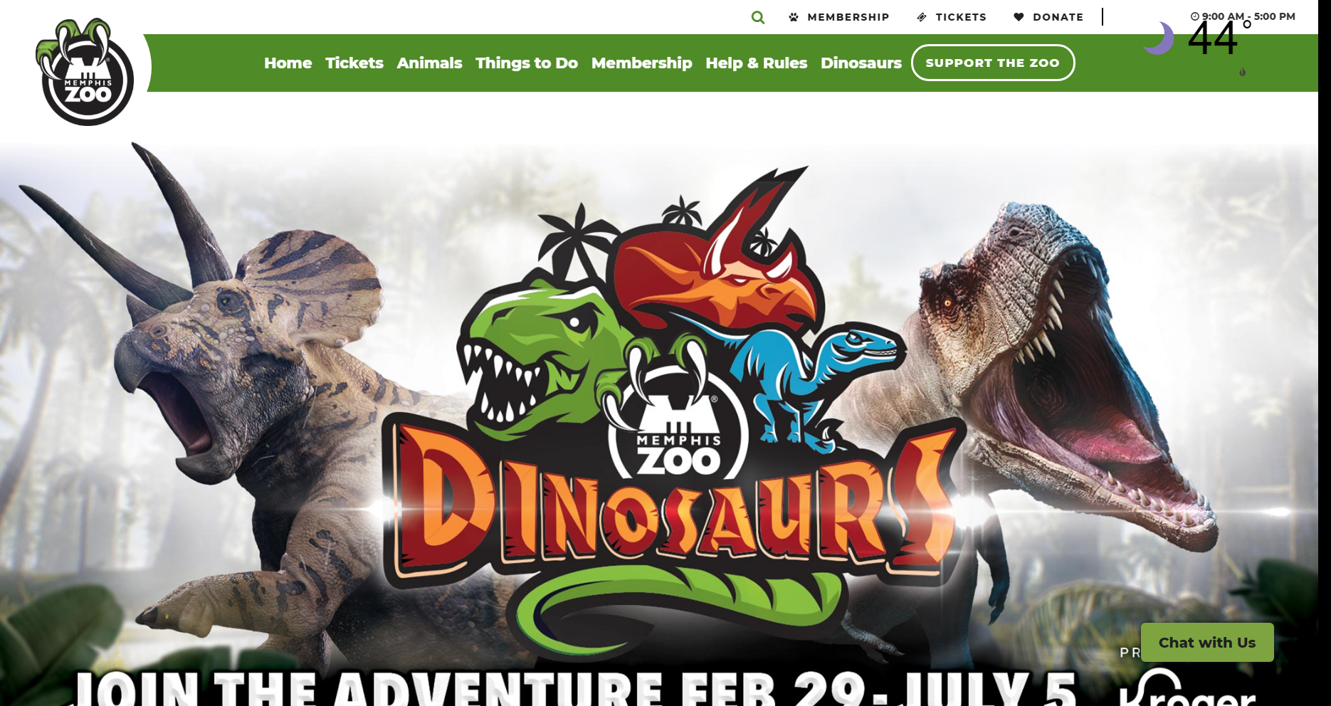

Figure 7: Memphis zoo's homepage

Along with being a home for animals, The Memphis Zoo is committed to all sorts of animal-related pursuits, from protecting endangered species to researching to improve zoo conditions and more.

They also host plenty of events and exhibits to bring their community together and to teach people more about animals and what they can do to protect them.

## Educational website

The websites of educational institutions and those offering online courses fall into the category of educational websites. These websites have the primary goal of either providing educational materials to visitors or providing information on an educational institution to them.

* Oracle Academy – <http://academy.oracle.com>

Oracle is a website through which students may develop key programming skills for college and career readiness.

* Coursera - <https://www.coursera.org>

Coursera provides online courses in the form of on-demand video lectures, homework exercises, and community discussion forums. Subscribers can get additional content including quizzes and projects as well as digital course certificates upon completion.

## Infopreneur website

Infopreneur websites overlap a bit with business and eCommerce websites, but they represent a unique type of online business. Infopreneurs create and sell information products. That could be in the form of courses, tutorials, videos or ebooks.

Examples of such websites include:

* Coursera
* Jazza studios
* Ross Draws

Which can be referred from precious sections

## Personal website

Not all websites exist to make money in some way or another. Many people find value in creating personal websites to put their thoughts out into the world. This category includes personal blogs, vlogs, and photo diaries people share with the world.

Here are some great personal site examples to refer

* Gary Sheng - <http://www.garysheng.com>
* Raf Darolez - <https://derolez.dev>
* Pascal van Gemert - <http://www.pascalvangemert.nl>

And two previously mentioned websites – Jazza studios and Ross draws

The common thing about personal websites is that they boast about the creator's skill because it’s a very easy way to reach out to people and companies. So showing off your skills and achievements is very important

## Web portal

Web portals are often websites designed for internal purposes at a business, organization, or institution. They collect information in different formats from different sources into one place to make all relevant information accessible to the people who need to see it. They often involve login and personalized views for different users that ensure the accessible information is most useful to their particular needs.

* West Bend, Agent and customer portal

Provides an enhanced digital offering for the customers and agents involved with the company.

* MedImpact, Benefit program portal

The portal centralizes authentication and authorization control across numerous sites that had been previously built to supply and manage various benefit programs.

* Grants.gov – Federal Government portal

This web portal Allows applicants for federal grants to apply for and manage funds online through a common website

## Wiki or Community Forum Website

Most people are familiar with wikis through the most famous example of one out there: Wikipedia. But wikis can be created on pretty much any subject you can imagine. A wiki is any website where various users can collaborate on content and all make their tweaks and changes as they see fit. There are wikis for fan communities, for business resources, and for collecting valuable information sources.

* Reddit – [www.reddit.com](http://www.reddit.com)

It is a network of communities based on people’s interests. People can create and be part of communities from around the world.

* Quora – [www.quora.com](http://www.quora.com)

Quora is a place to gain and share knowledge. It's a platform to ask questions and connect with people who contribute unique insights and quality answers.

* Stack Overflow – [www.stackoverflow.com](http://www.stackoverflow.com)

Stack Overflow is the largest, most trusted online community for developers to learn, share​ ​their programming ​knowledge, and build their careers.

* XDA Developers – [www.xda-developers.com](http://www.xda-developers.com)

It is a valuable resource for people who want to make the most of their mobile devices, from customizing the look and feel to adding new functionality. The forum was started in 2010 as a way to showcase the groundbreaking development and discussions going on about Android, Windows Mobile, and more.

* WikiHow - [www.wikihow.com](http://www.wikihow.com)

wikiHow is where most people with no idea of how to do something go to. It provides detailed articles on every possible subject people could think of supported by illustrations and available, as of March 2020, in 18 different languages.

# Website Assessment

## Internet Archive - [www.archive.org](http://www.archive.org)

The Internet Archive began its service in 1996. It was created to preserve websites that reach the web for future generations 50 or even 500 years from today.

## Amazon - [www.amazon.com](http://www.amazon.com)

Amazon is the world’s largest online market place, AI assistant provider and cloud computing platform

It was founded y Jeff Bezos in 1994 initially as an online bookstore. Soon it expanded to sell electronics, software, video, games and many more.

Also, Amazon distributes downloads and streaming of video, music, and audiobooks through its Amazon Prime Video, Amazon Music, and Audible subsidiaries. Amazon also has a publishing arm, Amazon Publishing, a film and television studio, Amazon Studios, and a cloud computing subsidiary, Amazon Web Services. It produces consumer electronics including Kindle e-readers, Fire tablets, Fire TV, and Echo devices.

## W3Schools – [www.w3schools.com](http://www.w3schools.com)

W3schools is a website created to teach people standardized web development so they can create web pages that follow the World Wide Web Consortium(W3C) web standards.

## WikiHow – [www.wikihow.com](http://www.wikihow.com)

WikiHow was created with one quality in mind; a how-to manual that anybody can read and edit. Furthermore, the service also aimed to provide ho-to manuals to people of all countries.

Figure 8: wikiHow in different languages

Currently, wikiHow has more than hundreds of thousands of articles. All which are available in 18 different languages including Arabic, Chinese, Czech, Dutch, English, French, German, Hindi, Indonesian, Italian, Japanese, Korean (Figure 1), Portuguese(Figure 3), Russian(Figure 2), Spanish, Thai, Vietnamese, and Turkish

All changes applied by users are always reviewed by personnel before being applied on a wikiHow and the same goes for new articles. WikiHow also provides illustrations and photographs for all articles for better explanations of how-to manuals.

Also, wikiHow provides expert reviews on selected articles. For example, some medical-related manuals are reviewed by actual medical doctors. Expert reviewed articles can be easily identified by a mark as shown in the figure below.

Figure 9 expert reviewed wikiHow article

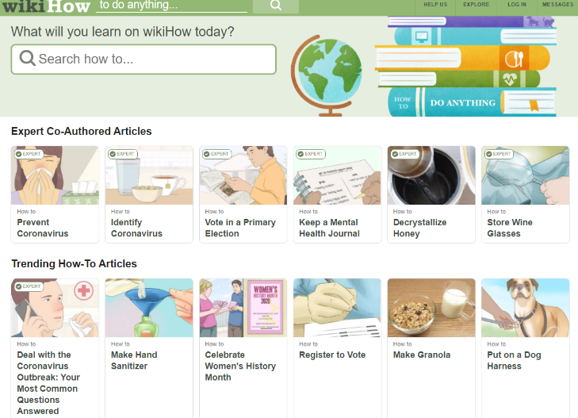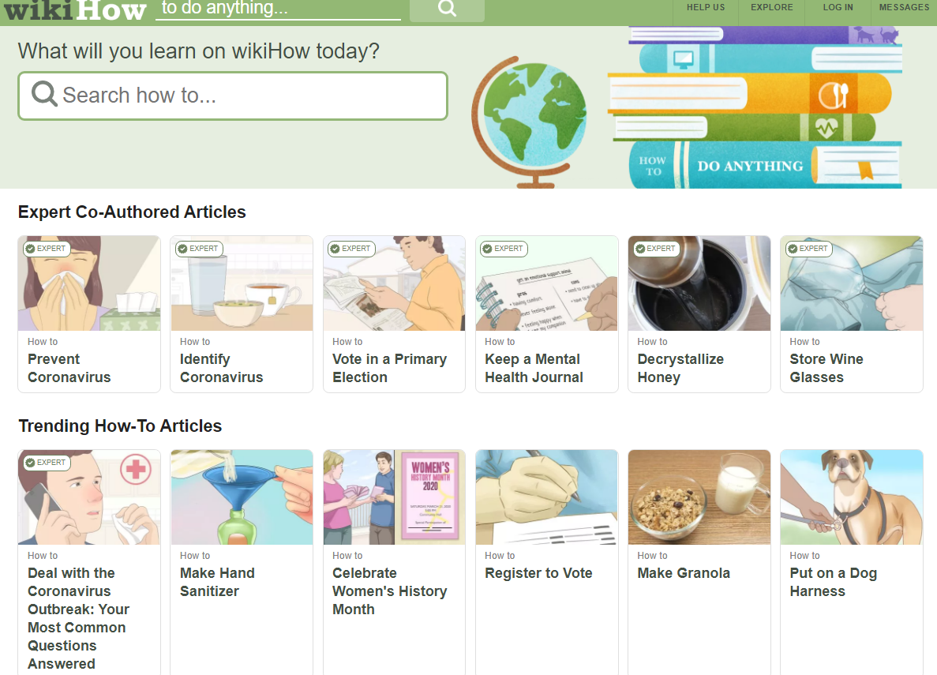

## Hulu - [www.hulu.com](http://www.hulu.com/)

Hulu is an American online video streaming site dedicated to streaming popular movies and reality television shows. The web service went live in august 2007 and it was at the time limited to American residents.

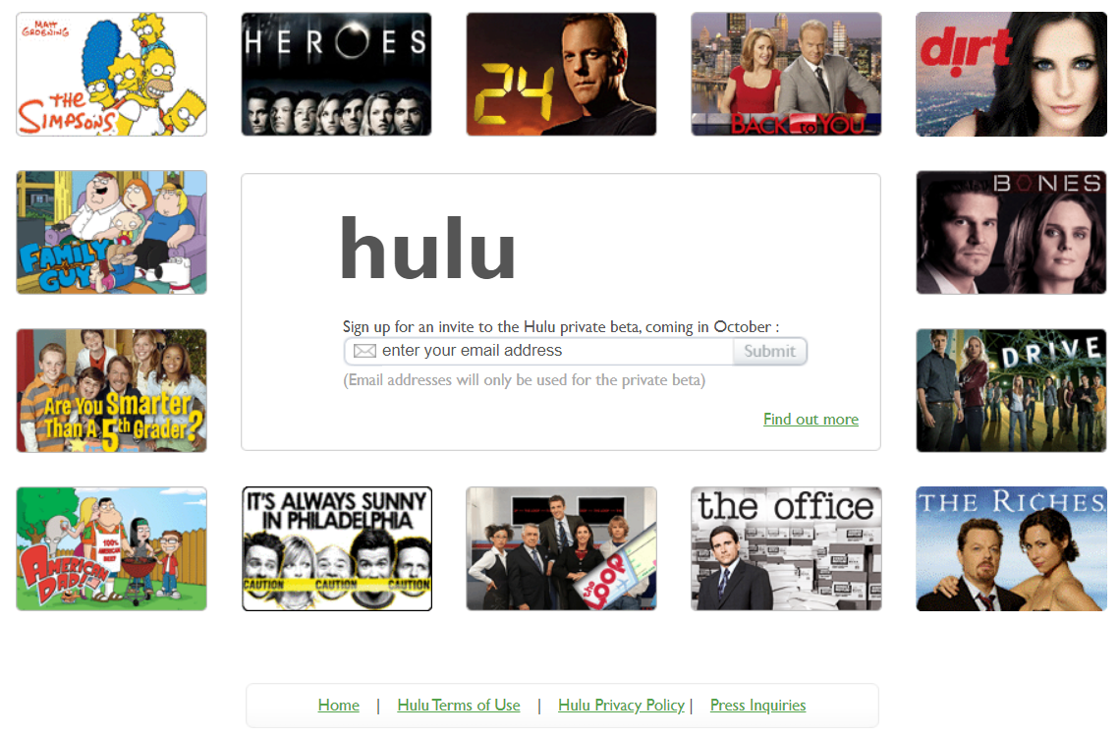

Figure 10: Hulu first release- August 2007 (Source: [Internet Archive](http://web.archive.org/web/20071020061930/http:/www.hulu.com/index.html))

However, the launch didn’t have any contents and instead it was intended to announce the beta test coming later that year in October. The beta release which came out later that year, in addition to the promised video streaming, it featured additional features such as video sharing. Through video sharing, Hulu lets users easily share their favorite videos via email or embed these videos on their website. Users can even choose to share the entire video or just one scene. By selecting the share or embed feature, users have the option of selecting their start and stop point in a video to create their fun video clips.

The service provided by Hulu was especially online video streaming hence it had various settings to play the videos. In the beginning, the service had three different preferences for the users to choose from:

1. watch the video in full screen
2. pop out the video player and place it anywhere on your computer screen and re-size it if you're multi-tasking
3. dim the lights and mute the rest of the browser window so nothing distracts you from the video that is being streamed

Unfortunately, the fourth option which allows viewers to stream in a window of its own didn’t appear until recently.

Until 2010 Hulu didn’t charge for streaming videos. Instead, the service was based around advertisements. The advertisement presentation, which was launched in 2008, Hulu’s service is very appreciable as the advertisements play at times when no video is streaming and when the video is paused. After Hulu converted the streaming services to a subscription-based, it was made possible to opt-out of all forms of advertisements and data collections for subscribers. To achieve this, Hulu uses a Trackermap - a service provided by evidon. As you can see from the figures below, it is also possible to choose from a list of advertising services and disable the ones the user is not comfortable with.

Figure 11:Hulu's Tracker map

# How to evaluate websites

Six guidelines deal with the content of websites rather than the design and look.

## Authority

Authority reveals that the person, institution or agency that owns a site has the qualifications and knowledge to do so. It should also be clear who developed the site. Also, contact information should be provided and it must include an e-mail address, phone number, and fax number. The author should state qualifications, credentials, or personal background that gives them the authority to present information. It is also important to mention whether the site is supported by a commercial body or an organization.

## Purpose

The purpose of the information presented in the site should be clear whether the web site is meant to inform, persuade, state an opinion, entertain, or parody someone. When evaluating a site for the purpose, it is important to check:

* If the information is intended to a particular audience
* Whether the content supports the purpose of the site
* If the site is organized and focused
* If the outside links are appropriate for the site
* Whether the site evaluates the links
* To see the domain of the site as it may indicate the purpose of the site

## Coverage

It is difficult to assess the extent of coverage since depth in a site, through the use of links, can be infinite. One author may provide in-depth coverage of a topic while another may cover just one part of the same topic. When evaluating a site for the coverage, it is important to check:

* Whether the site claims to be selective or comprehensive
* If the topics are explored in-depth
* The value of the site’s information as compared to other websites of similar topic
* How many links are provided instead of its own
* If there are any irrelevant outside links

## Currency

The currency of a web site can be described in different aspect including

1. How current the information provided on the website is
2. Whether the web site is maintained
3. How often the website updated

When evaluating a website for the currency, it is important to find the date information was:

* First written
* Placed on the web
* Last updated

Afterward check if:

* Links are up-to-date
* Links provided should be reliable as dead links or references to sites that have moved are not useful.
* Information provided is so trend related that its usefulness is limited to a certain period
* The site has been under construction for some time

## Objectivity

A site should be very clear with its objectives. Objective sites present information with a minimum of bias. When evaluating a site for the objectivity, it is critical to check:

* If the information is presented with a particular bias
* Whether the information provided assumes a biased audience or tries to sway the audience
* Whether site advertising conflicts with the content of the site
* If the site trying to explain, inform, persuade, or sell something

## Accuracy

There are a few standards to verify the accuracy of the information on the web. Nevertheless, it is the responsibility of the audience to assess the information presented. When evaluating a site for accuracy, it is critical to check:

* Reliability: Is the author affiliated with a known, respectable institution?
* References: do statistics and other factual information receive proper references as to their origin?
* Whether the reading you have already done on the subject makes the information seem accurate
* If the information is comparable to other sites on the same topic
* Whether the text follows basic rules of grammar, spelling, and composition
* If there is a reference(bibliography) list included

# References

A timeline on the History of the Internet - <https://www.behance.net/gallery/6310935/History-of-the-Internet-Infographic>

Internet | Description, History, & Facts | Britannica - <https://www.britannica.com/technology/Internet>

wikiHow: How-to instructions you can trust - <https://www.wikihow.com/Main-Page>

About wikiHow – wikiHow - <https://www.wikihow.com/wikiHow:About-wikiHow>

Internet Archive- Wayback Machine- Hulu -<http://web.archive.org/web/20080202191823/http://www.hulu.com/splash/about.html> <http://web.archive.org/web/20120615022645/http://www.hulu.com/about> <http://web.archive.org/web/20071026015638/http://www.hulu.com:80/> <http://web.archive.org/web/20200225013411/https://info.evidon.com/pub_info/3920?v=1&nt=0&nw=false>

Wikipedia - <https://en.wikipedia.org/wiki/Hulu>

Business Services in the world - <https://www.similarweb.com/top-websites/category/business-and-consumer-services/business-services>

6 Criteria for Websites - <https://cdn.dal.ca/content/dam/dalhousie/pdf/library/CoreSkills/6_Criteria_for_Websites.pdf>

Math riddles - <https://www.riddles.com/math-riddles>

Four-player chess - <https://www.chess.com/4-player-chess?t=play>

28 amazing design portfolios to inspire you | Creative Bloq <https://www.creativebloq.com/portfolios/examples-712368>

The Top 13 Nonprofit Websites: Illuminate Your Cause <https://doublethedonation.com/tips/top-nonprofit-websites/>

The Memphis Zoo - <http://www.memphiszoo.org>

Malala Fund – <http://www.malala.org>

Coursera - <https://about.coursera.org>

Oracle Academy – <http://academy.oracle.com>

23 of the Best Personal Websites to Inspire Your Own <https://blog.hubspot.com/marketing/best-personal-websites>

16 Awesome Web Portal Examples | Digital Strategy | Liferay Blogs <https://www.liferay.com/blog/en-us/digital-strategy/16-awesome-web-portal-examples>

About XDA Portal - <https://www.xda-developers.com/about/>

Amazon (company) – Wikipedia - <https://en.wikipedia.org/wiki/Amazon_(company)>